Skill based assessment and evaluation

CTS is a global leader in business and technology services and is a member of the NASDAQ-100, the S&P 500, the Forbes Global 2000 and the Fortune 500 and is ranked among the top performing and fastest growing companies in the world.

ACADGILD provides instructor led online trainings and skill based assessment services to corporate clients.

CTS and AcadGild are in a discussion for a potential partnership wherein ACDGILD will provide Skill Based Assessment service to CTS.

Pilot for evaluating Cognizant’s Front end technology associates

Contents

Skill based assessment and evaluation 0

1 Overview 2

2 Scope of the SBA 2

2.1 Core SBA Functionalities 3

2.2 Performance Report: 3

2.3 Nonfunctional Requirements 5

2.4 How will SBA work 5

2.5 Approval Process 6

3 Acadgild deliverables 7

4 Timeline 7

5 Workflow 7

6 Risks and mitigation plans 8

7 Commercials 8

7.1.1 SBA Development 8

7.2 Evaluation service 8

• 15% of service Tax is not included in the above quote 9

• 30% of Advance payment will be required to initiate the project work 9

# Overview

CTS associates from various BUs have undergone internal trainings on front-end technologies. L&D departments of CTS now want to assess effectiveness of these trainings by conducting Skill Based Assessments(SBA) of trained associates. To furnish this task, CTS L&D team is exploring training partners who can provide robust Skill based assessment and evaluation services.

* SBA Technology stack-  Angular.JS, Node.JS, RESTful web services along with MySQL or MongoDB
* SBA Target Audience- CTS front-end technologies associates
* SBA Duration- 3 Hours
* SBA Commencement date- 2nd week of July 2016
* Number of associates that will be assessed by SBA - 300

# Scope of the SBA

* Though, the associates have gained a fair understanding of the front end technology concepts, their deployment in live projects is still not deterministic.
* The L&D team at CTS has identified this problem and are looking for ways to develop a solution which will deliver a robust assessment mechanism to determine the project readiness of the associate
* A resource (or associate) will have to undergo an examination for 3 hours in the premises of CTS and will have to develop a Web-based application to demonstrate his/her skills which were gained as part of a self- paced e-learning at CTS.
* The scope of the assessment examination is to design a case study which will consist of implementation of web technologies or frameworks viz. AngularJS, NodeJS, MongoDB, MySQL, RESTful web services.
* The resource who will be tested will be provided with all the necessary templates and a local server to deploy the application and check the solution on a Web-browser.
* After the assessment, certain mandatory standards of developing a Web-based application which will be identified by all the stakeholders involved will be used to grade the solution developed by the associate.
* Based on the results from the assessment, a resource will be either determined to be deployed to a project or will be re-trained on the concepts of the Web-technology that he/she has a partial understanding. This will continue in an iteration and will only end once the associate has proven his skills in the technology and the standards laid out.

## Core SBA Functionalities

The proposed solution must be able to

* Identify a resource’s current level of understanding in a particular technology of the Web.
* Must report effectively the expertise of the associate in solving problems
* Determine the ability of the associate to develop a comprehensive solution to the case study presented to him/her.
* Analyze the associate’s current standing in developing the program by following all the standards pertaining to it.
* Determine if the associates need to be part of a skills improvement training program or can be deployed to a project

## Performance Report:

#### Assessment will focus on following aspects:

* Functionality - Does the code written by associate meet desired Case Study outcome in total?
* Readability & Maintainability - Has the code been properly formatted, commented and has followed consistent naming convention?
* Performance & Portability - How fast does the webpage take to load? Are we making too many back & forth requests? Has the code been properly modularized?
* Security - Has the input data been validated for threats like SQL injection and Cross site scripting? Has sensitive data been encrypted before sending to server?
* Below mentioned factors will be taken into account when generating the performance report of an individual associate. Top performers in the program will get one of platinum, gold, and silver medals. Medal distribution is as follows:
  + Platinum: >85%
  + Gold: 75-85%
  + Silver: 70-75%

|  |  |  |
| --- | --- | --- |
|  |  | Max Marks |
| Technology skills |  | 100 |
| AngularJS | 40 |
| NodeJS | 40 |
| MongoDB or MySQL | 10 |
| Restful API | 10 |
| Programming skills |  | 100 |
| Functionality | 40 |
| Performance | 20 |
| Readability & Maintainability | 20 |
| Security | 20 |

* We can customize the associate’s reporting criteria as per inputs from Cognizant L&D and BU teams
* Over and above detailed individual reports, we will also provide bell curve analysis and e-learning content efficacy reports

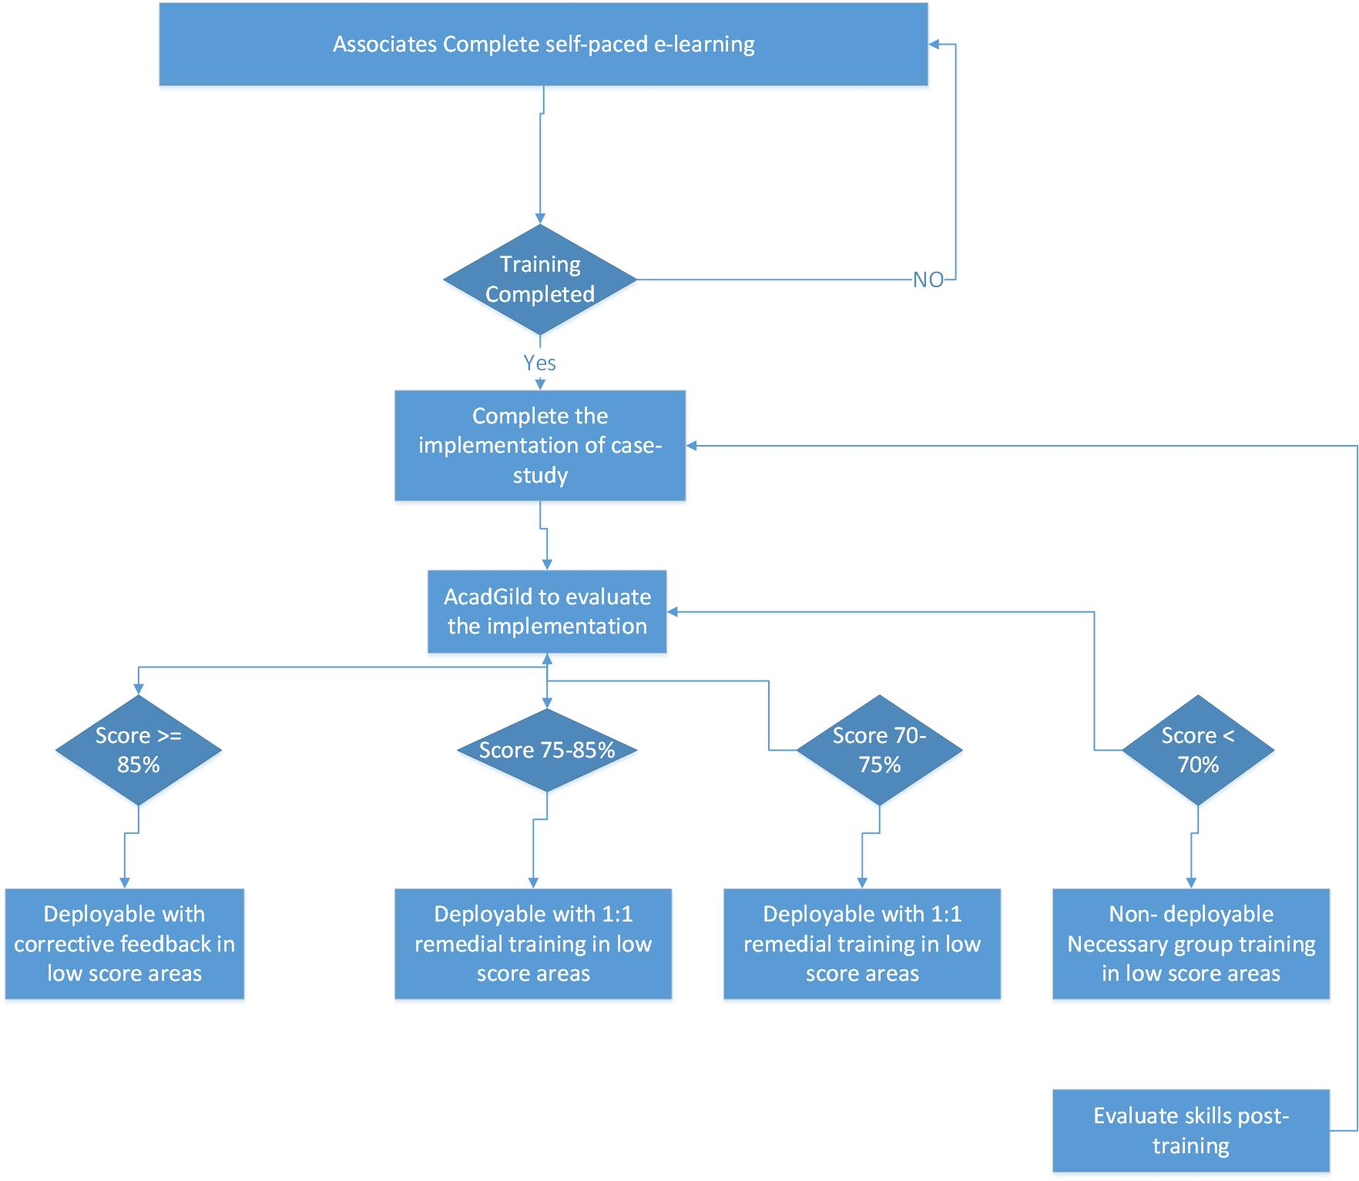

## Nonfunctional Requirements

* It is assumed that associate has basic knowledge of Angular.js, RESTful web services, MongoDB/MySQL and Node.js
* The developer should not invest time in setting up the SBA.
* All the required templates for starting to code for the intended application should be provided

## How will SBA work

1. The associate will be provided with the AcadGild SBA Package.
2. The package will contain the case-study of the targeted application and will also describe the files part of the package.
3. Once the associate understands the case-study, he/she will develop the program against the technology stack described.
4. The program will be submitted to the CTS servers in the intranet.
5. AcadGild will have access to these servers using which the programs developed will be downloaded and assessed.
6. Post evaluation of the programs, individual reports will be generated for the associates which will describe the performance of the associate in various aspects of the application development.

## Approval Process

1. AcadGild submits the draft of the case study which describes the web-based application to be developed by the associates.
2. This document will be reviewed by the relevant stakeholders at CTS viz. L&D Heads, BU team etc.
3. After receiving the approval for the draft version, AcadGild will submit the final copy of the case study with the review comments implemented

# Acadgild deliverables

* Case Study - AcadGild will provide a detailed case study document. This case study will be developed by ACADGILD SME as per initial inputs from CTS BU.
* Two variations of this case study will be created - One with SQL and one with NoSQL as backend.
* Project Skeleton - AcadGild will also provide a skeleton project(template) for this case study. This will ensure that associate do not have to spend more than 15 minutes in installing software and setting up of project.
* Performance/Evaluation report of 300 candidates

# Timeline

This section describes the timelines agreed among all the stakeholders for the final delivery.

|  |  |
| --- | --- |
| Submission of First Draft | 25th June, 2016 |
| Submission of Second Draft | 1st July, 2016 |
| Submission of Final Version | 6th July, 2016 |
| Implementation | 12th July, 2016 |

# Workflow

* Case Study Development
  + AcadGild interacts with L&D AND BU team
  + AcadGild submits draft of case study and provides revision
  + L&D AND BU team approves it
* Assessment
  + Developer opens AcadGild SBA package on his machine
  + Developer Understands the case study
  + Writes code- only for mentioned technology stack
  + Submits code on Cognizant server
* Evaluation and Reporting
  + AcadGild downloads the code from Cognizant server
  + AcadGild evaluate each and every code assignment on above mentioned criterias
  + AcadGild prepares performance reports along with need-gap analysis and remedial solutions

# Risks and mitigation plans

#### Risk 1: Implementation site not under AcadGild

Since the implementation site is not directly managed by AcadGild, a trial run will be conducted to ensure flawless functioning of the proposed SBA. This will also uncover any other unseen risks involved in the SBA and will allow for easy functioning on the day of implementation.

#### Risk 2: Lack of surveillance

Since candidates are remotely located and will get assessed on same functional requirements, there is a possibility of infringement. To handle this issue we will seek support from CTS team in distributing test-seekers appropriately and in blocking access to internal chat-clients and websites like stack overflow

#### Risk 3: Tight schedule

Due to limited availability of time for development and iterations, there may be a gap between the CTS L&D team’s expectations and AcadGild’s actual delivery. In order to bridge the gap we will seek as much clarity as possible in first few days of confirmation. In order to make sure timely delivery of both case study and individual SBA reports, we will have 24*7 dedicated support team for CTS

# Commercials

## SBA Development

|  |  |
| --- | --- |
|  | Ownership Model |
| Less than 200 students | INR 40000 |
| 200-500 | 50% Discount |
| 500-1000 | 75% discount |
| Above 1000 | 100% discount |

## Evaluation service

|  |  |  |
| --- | --- | --- |
|  | Pay-per use | Ownership |
| Less than 200 | INR 2499 | INR 2299 |
| 200-500 | INR 2199 | INR 2099 |
| 500-1000 | INR 1999 | INR 1949 |
| Above 1000 | INR 1499 | INR 1499 |

### 15% of service Tax is not included in the above quote and will be charged extra

### 30% of Advance payment will be required to initiate the project work